Supplementary material

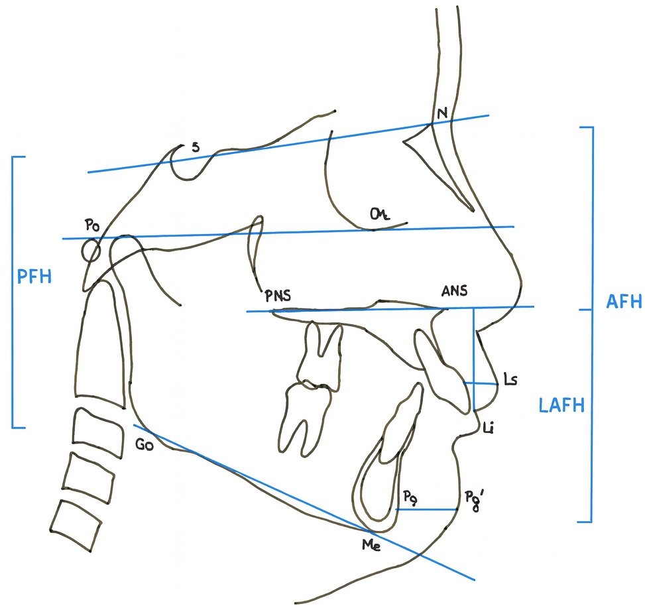
Supplementary Fig. 1. Skeletal, dental, and soft tissue measurements. AFH: anterior facial height; LAFH: lower anterior facial height; PFH: posterior facial height.

